Tech Stack: Lumen Platform (for Claude, Antigravity and plugins)
Oct 16, 2026 · @Sehar

1. Stack at a Glance
The recommended stack is TypeScript end to end, browser-native, with no required backend. It follows the PRD: offline-first, WebGPU/WASM, peer-to-peer and self-sovereign credentials.
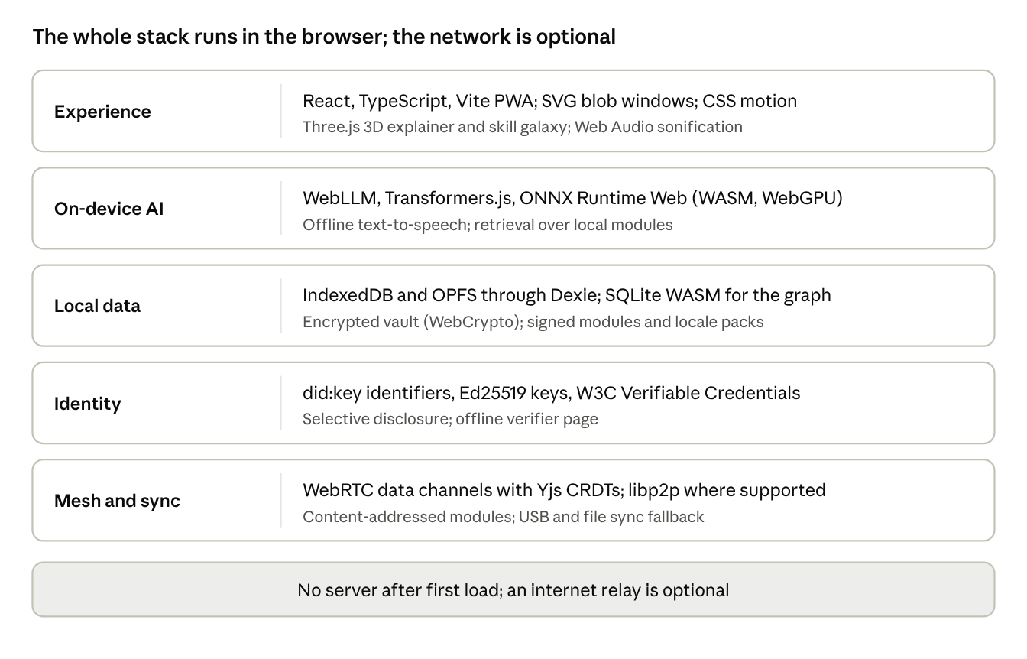
stack layers · 5 layers, offline by default
Each layer maps to PRD pillars: Experience to 1 and 3 and the 3D Explainer, On-device AI to 2 and 4, Local data and Identity to 5, and Mesh to content sharing across all of them.

2. Recommended Stack by PRD Area
Choices favor small bundles, open licences, strong TypeScript typing (which AI coding agents handle well) and offline operation. Versions should be pinned at project start; confirm each licence before adoption.
PRD area | Recommended | Why
Language and build | TypeScript (strict), Vite, pnpm workspaces monorepo | One language across app, packages and tooling; fast builds; clear package boundaries for agents
App framework | React with a light router, installable as a PWA with a service worker (Workbox) | Largest ecosystem and agent familiarity; works offline after first load
Styling and UI | CSS variables as design tokens, SVG for blob windows, CSS and Web Animations API for motion | Matches the ink-and-cosmos design doc; tiny assets; easy reduced-motion handling
Pillar 1: load sensing | Custom on-device signal pipeline in TypeScript; a small classifier in ONNX Runtime Web | No raw telemetry leaves the device; model weights stay inspectable
Pillar 2: local translation | WebLLM or Transformers.js with quantized small models (WebGPU, WASM fallback); retrieval over local module text | Runs in the browser; model tier chosen by device RAM
Pillar 3: sensory mapping | Web Audio API (with Tone.js if helpful) for sonification; Canvas and Three.js for visual simulations | Browser-native; no plugins
3D Explainer | Three.js, glTF models compressed with Draco or Meshopt and KTX2 textures; a shared step-timeline format driving camera, highlights, audio and captions | Meets the 2 MB per explainer budget; one timeline serves both modes
Narration and speech | Offline text-to-speech (Piper compiled to WASM, or the Web Speech API where present); optional recorded audio packs | Dialect support depends on the voices available; needs early testing
Pillar 4: perspective simulation | Scenario files (JSON with cited sources) run by the local model with strict retrieval; a rules layer for guardrails | Keeps agents grounded and citations traceable
Local storage | IndexedDB and OPFS via Dexie; SQLite WASM for graph queries; WebCrypto for the encrypted vault | Durable, queryable, learner-owned
Pillar 5: skill-graph | Graph in SQLite or in-memory, drawn with Three.js; 2D fallback in SVG | Same data, two renderers, matching the device tiers
Identity and credentials | did:key identifiers, Ed25519 signatures, W3C Verifiable Credentials | No central issuer; offline verification
Mesh and sync | WebRTC data channels with Yjs CRDTs; libp2p where supported; content-addressed module packages; USB and file import as fallback | Matches the P2P goal; fallback covers mobile-browser limits
Testing | Vitest, Playwright, axe-core, Lighthouse CI | Unit, end-to-end, accessibility and performance gates
Optional dev backend | None required; a tiny static host or relay for first install and optional sync | Keeps the offline-first promise
Note on 3D. Three.js is recommended over a full game engine to keep the base install small and the code approachable for contributors.

3. Repo Structure and Conventions for AI Agents
One monorepo with small, single-purpose packages and one shared instruction file lets Claude Code, Antigravity and Claude plugins all work from the same rules.
lumen/
AGENTS.md shared instructions (single source of truth)
CLAUDE.md short file that points to AGENTS.md
GEMINI.md optional, only if Antigravity needs its own notes
.agents/
rules/ Antigravity workspace rules
skills/ shared skills, one folder per skill with SKILL.md
.claude/
skills/ Claude Code skills (synced from .agents/skills)
apps/
web/ the PWA (React, Vite)
packages/
load-engine/ cognitive-load signals and classifier
local-ai/ model loading, retrieval, translation, speech
explainer/ 3D explainer runtime and step-timeline format
sensory/ Web Audio and visual simulation engines
skill-graph/ graph model, 3D and 2D renderers
identity/ DIDs, keys, verifiable credentials
mesh/ WebRTC, CRDT sync, module packaging
ui-tokens/ design tokens from the design doc
content/
modules/ lessons, explainers, scenarios (signed)
locale-packs/ dialects, analogies, stories
docs/ PRD, design doc, tech stack, decision log
tools/ scripts, CI helpers
Conventions that help agents
- One source of instructions. Put build, test and style commands, the architecture map and the hard rules (privacy, offline, budgets) in AGENTS.md. Keep CLAUDE.md and GEMINI.md to a line or two that point to it. Antigravity limits each rules file to 12,000 characters, so keep files short and split detail into rules and skills.
- Small packages with typed public APIs. Each package exports a narrow interface and has its own README and tests; agents can work in one package without loading the rest.
- Strict TypeScript and lint on every save. Type errors give agents fast, reliable feedback.
- Hard budgets in code. Bundle size, model size, 2 MB per explainer, first-screen time and 30 fps targets run as CI checks, so an agent cannot silently break them.
- Decision log. Every non-obvious choice gets a short dated note in docs, so a new agent session does not reverse it.
- No network calls by default. A lint rule and a test fail the build if code reaches an external host, protecting the offline and privacy promises.

4. Working with Claude Code, Antigravity and Claude Plugins
The three tools read the same kinds of files in different places, so the repo keeps one canonical copy and a small sync script.
Need | Claude Code and plugins | Google Antigravity
Standing instructions | CLAUDE.md in the repo (point it to AGENTS.md) | AGENTS.md or GEMINI.md in the project root; rules in .agents/rules/ (older .agent/rules/ still works); global rules in ~/.gemini/GEMINI.md
Skills | skills/<name>/SKILL.md inside a plugin; also project and user skill folders | .agents/skills/<name>/SKILL.md in the workspace; ~/.gemini/config/skills/ globally
Skill format | SKILL.md with a name and a description that says when to use it | SKILL.md with frontmatter: description (required) and name (optional)
Subagents | agents/*.md with frontmatter in a plugin | Custom agent Markdown files (agent.md); location not confirmed in the pages I read
Hooks | hooks/hooks.json in a plugin | Not confirmed
MCP servers | .mcp.json at the plugin root | Supported by the IDE; configuration location not confirmed in the pages I read
Manifest | .claude-plugin/plugin.json (optional; only name is required) | None needed
Recommended setup
- Write AGENTS.md once; keep CLAUDE.md as a short pointer (Claude Code can import another file into CLAUDE.md; confirm the exact syntax in its current docs).
- Keep shared skills in .agents/skills/ and copy them into .claude/skills/ with a sync script run in CI, so neither tool drifts.
- Package the project's own skills as a Claude plugin (lumen-dev) so every contributor gets them on install.
- Treat each skill as a small, testable procedure.
Skills worth writing for this project
Skill | What it makes agents do
add-explainer | Turn a glTF model, step list and script into an explainer module with both modes, captions and size check
add-locale-pack | Create a dialect and analogy pack with the review checklist and bias audit
add-scenario | Build a perspective simulation with cited sources and the consensus reveal
design-tokens | Apply the ink-and-cosmos tokens and check contrast and reduced-motion
perf-budget | Run the bundle, model and frame-rate checks and report regressions
credential-check | Verify signing, selective disclosure and offline verification flows
Plugin contents (lumen-dev). A skills/ folder with the skills above, an agents/ folder with a reviewer (accessibility and privacy) and a content checker, hooks/hooks.json to run lint and type checks after edits, and .mcp.json for any local tool servers such as a model-size inspector. Reference bundled files with ${CLAUDE_PLUGIN_ROOT}.
Sources (pages opened). Claude Code plugins reference; Antigravity rules guide (third-party); Authoring Antigravity skills (Google codelab). Antigravity details come from these pages and should be re-checked against its official docs.

5. Testing, Performance Budgets and CI Guardrails
Every PRD promise that can regress becomes an automated check, so agents get a clear pass or fail on their own changes.
Check | Tool | Gate (from PRD and design doc)
Types and lint | TypeScript strict, ESLint | No errors; network-call rule passes
Unit tests | Vitest | Packages meet agreed coverage; load engine, identity and mesh logic fully tested
End-to-end offline | Playwright with the network disabled | Every P0 flow works with zero connectivity
Accessibility | axe-core in Playwright; manual screen-reader pass | WCAG 2.2 AA; no text over illustration
Performance | Lighthouse CI and a frame-rate probe | First interactive screen under 3 s on the reference device; 30 fps for ambient layers; initial UI assets under 5 MB
Size budgets | Bundle analyzer in CI | Base install under 150 MB; explainer under 2 MB after compression
Model quality | Fixed test sets reviewed by native speakers | Translation fidelity and no fabricated quotes in scenarios
Credentials | Signing and verification tests, offline verifier | A third party validates a credential with no internet
Privacy | Test that no telemetry leaves the device | Zero outbound requests in default mode
Reference device. Define one real 3 GB RAM Android phone as the test target and run the performance and offline checks on it, not only on a laptop.
Human review stays in the loop. Agents may open pull requests, but content (locale packs, scenarios, explainers) and credential logic require a named human reviewer.

6. Alternatives, Risks and Open Decisions
Alternatives considered
Choice | Alternative | Why not the default
React | Svelte or SolidJS | Smaller bundles, but fewer contributors and less agent familiarity; worth revisiting if bundle budgets are tight
Three.js | Babylon.js, or a game engine export | Heavier or harder for contributors; Babylon is a reasonable second choice
WebLLM / Transformers.js | llama.cpp compiled to WASM | Good CPU fallback; keep as the low-end path
WebRTC and Yjs | Plain peer sync, or a hosted backend | A hosted backend breaks the offline promise; keep an optional relay only
TypeScript monorepo | Separate repos per package | Harder for agents to see cross-package effects
Risks
- Browser support for WebGPU and mesh transports varies, especially on iOS, so the CPU and file-sync fallbacks must be real, not afterthoughts.
- Small local models may be too weak for dialect work; plan for retrieval, human-reviewed packs and recorded audio.
- Offline text-to-speech voice quality and dialect coverage are uneven and must be tested early.
- Agent tooling changes quickly; keep instructions in plain Markdown files and keep tool-specific setup thin.
Open decisions
- Which licence for code and for content?
- React or a lighter framework, once the first bundle measurements exist?
- Which 3 GB reference phone?
- Which model families are allowed (licence, size, language coverage)?
- Where do Antigravity's MCP and workflow settings live in the version your team uses? Check its official docs before wiring them up.

